Chapter 1, Solution 12

For 0 < t < 6s, assuming q(0) = 0,

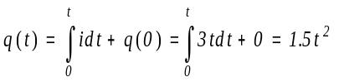
At t=6, q(6) = 1.5(6)² = 54
For 6 < t < 10s,

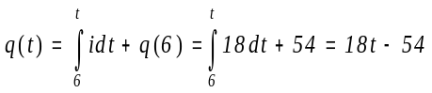
At t=10, q(10) = 180 – 54 = 126
For 10<t<15s,

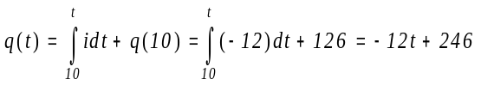

At t=15, q(15) = -12x15 + 246 = 66
For 15<t<20s,

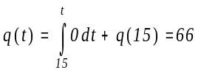
Thus,

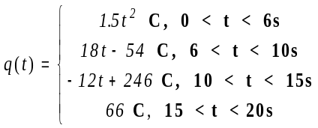

The plot of the charge is shown below.
